# **TASK ASSIGNMENTS**

*Tasks*

* Creation of a transaction log table
* Server management : mySQL, SQLserver
* Maintain Transactions with UserID, acc. number, routing number, current balance, transaction log
* Build and query database scripts
* Create a new instance of a user account
* Utilization of one data object to store a action
* Checking and Saving Account
* User Authentication : UserID, username, password
* user authentication recover password using email
* *Templates for Front-End*

Latest Meeting (02/22/22):

* Josh: Finished table creation, altering table and insert statements, currently working on update queries and select queries
* Mohummad: finished templates as per specification of original database design
* Brandon and Gabriel: Beginning work on complex accessor functions and coming up with requests for SQL Queries for Josh
* Sabelo: Request functionality from Front end to see what types of accessor functions need to be created

# **RESOURCES**

**Video: How to set up MySQL database**

<https://www.youtube.com/watch?v=kphq2TsVRIs&ab_channel=DatabaseStar>

**Video: Java Bank App UML (*23 minutes, skimmable*)**

<https://www.youtube.com/watch?v=PnMjInhZT3o&list=PL1nur_zBzme7naZAUEB0TJ9kvpS-vDsAO&index=2>

**Video: Java Bank App - MySQL Database Building (*Part 1: 10 minutes*)**

<https://www.youtube.com/watch?v=hCAmNg2AjcY>

**Article: Build a Bank Database using SQL (*1 minute read*)**

<https://inblog.in/Build-a-Bank-Database-using-SQL-Uc6hHUFt8N>

**Video and Article: What is Backend Development: Skills, Salary, Roles & More**

**(*Video: 10 minutes, Article: 5 minute read*)**

<https://bit.ly/3H10yOG>

**Article: What does a back-end developer do? (*2 minute read*)**

<https://www.careerexplorer.com/careers/back-end-developer/>

**Article: The Beginner’s Guide to Backend Development (*20 minute read, skimmable*)**

<https://learntocodewith.me/posts/backend-development/>

**EXAMPLE BANKING SYSTEM UMLS**

*\*Note: best UML located in Java Bank App Video\**

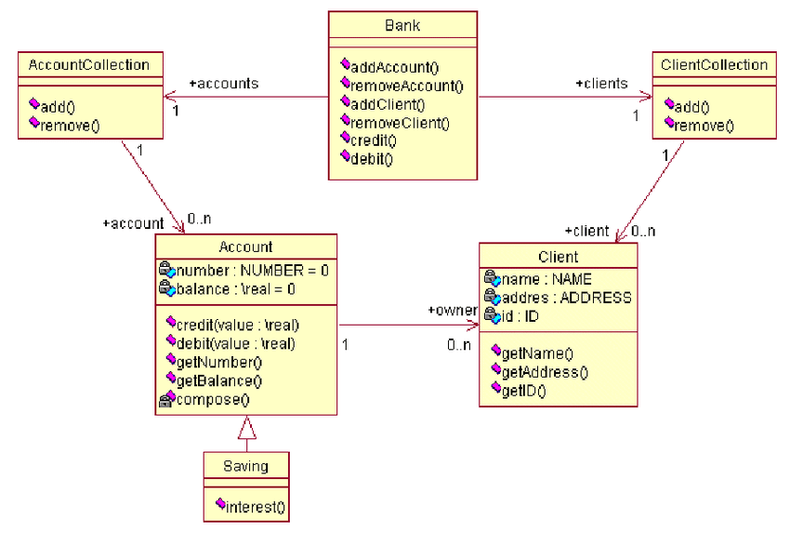

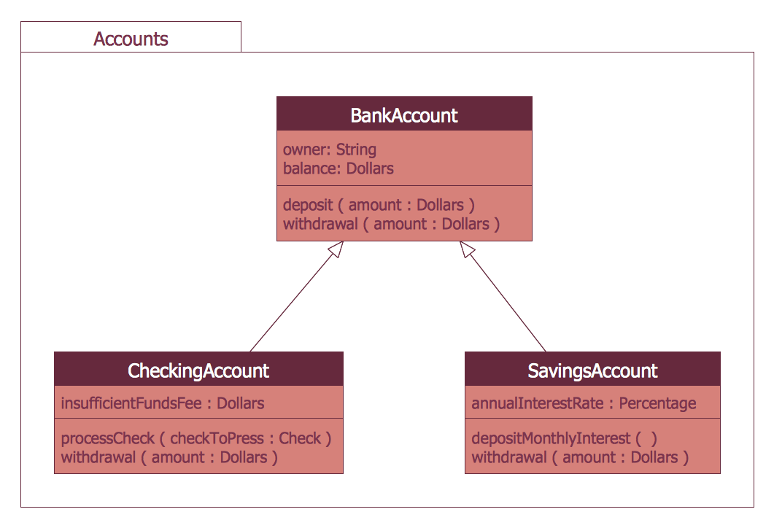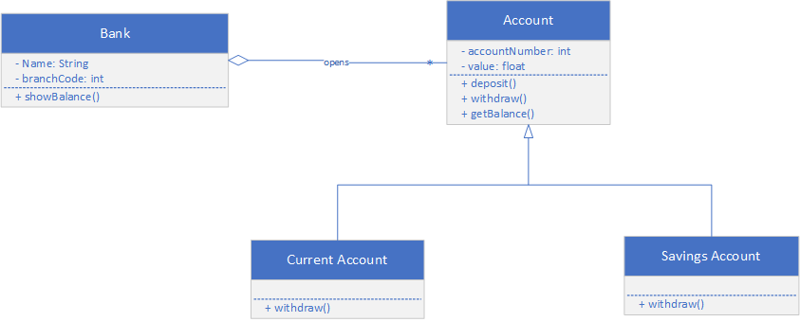

**DATABASE DESIGN**

**p**

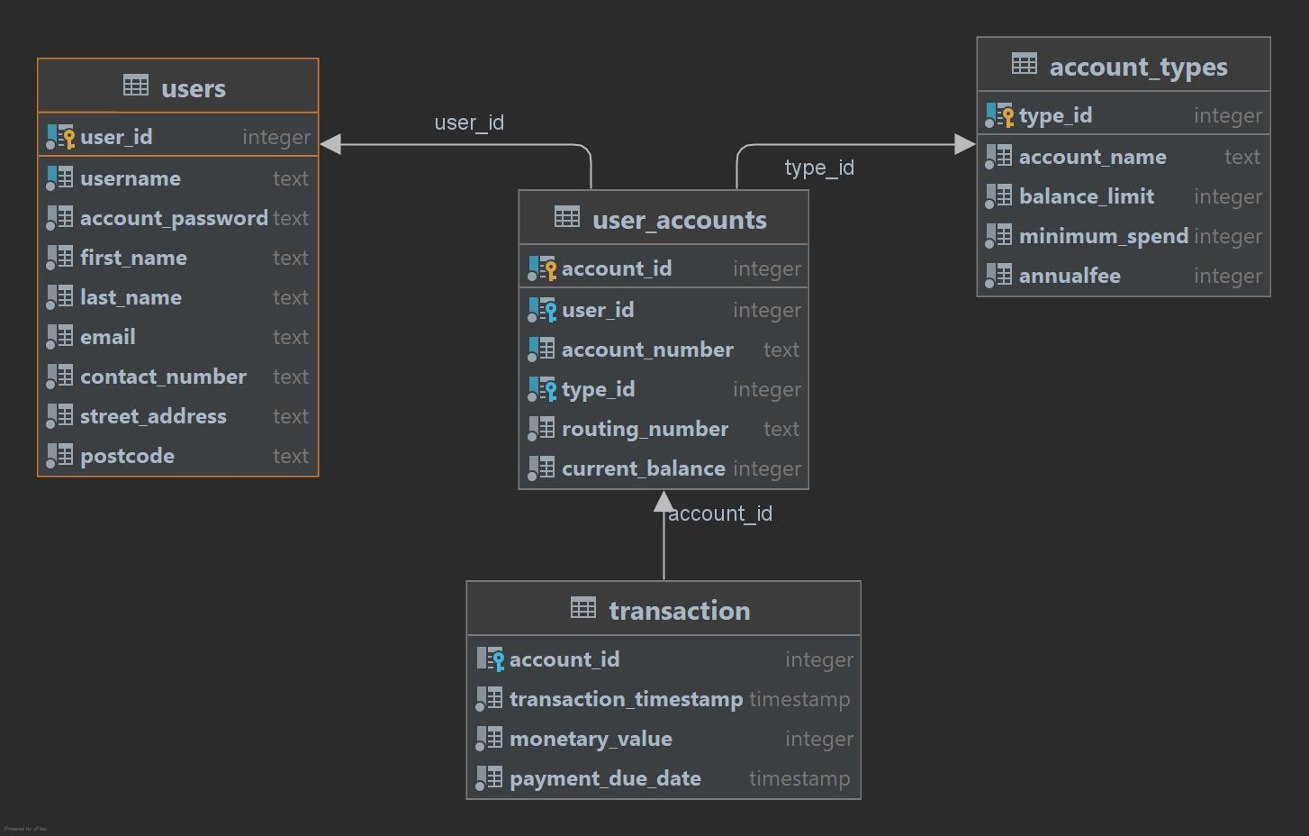

**WHAT IS BACKEND DEVELOPMENT?**

Backend Development is a web development activity that involves server side development of web application logic, integration and activities. It consists of three parts that a user never sees: a server, an application, and a database. Contained within this is the building and maintenance of code that is designed to communicate between a database and an application. Backend developers are responsible for managing data consistency and integrity, focusing on web architecture, scripting and writing code, as well as maintaining security and preventing hacks as their primary roles.

There are various forms of backend developers including: DevOps Engineer (formally a backend process), Java Developer and iOS Developer.

Backend Developers lie within a certain dichotomy, that of Front-end Developer vs. Back-end Developer. There’s also a type of developer that has the skills and capacity to manage both sides of development and that position is called Full-Stack Developer. Our role is to build and maintain the technology which will serve as the backbone of the front-end side of the project. The back-end side of the project consists of the server, application, and database – and our goal is to provide the most efficient program that is able to communicate between all three services. This can be done through various coding languages that serve their own purpose – such as, PHP, Python, Java (the language we will use), and .Net (which serves to build the application) and tools like MySQL, Oracle, and SQL Server (which provides, changes, and integrates data within our project).

Some of the primary skills that are required to be a backend developer include creating code that does relational mapping (coding for databases - forms include stacks, queues, trees and graphs, sorting and searching), having an in-depth understanding of backend programming languages (e.g. Java, Python, C#, PHP, Perl, Ruby, etc.) so that day-to-day tasks involving frontend developers are easier to handle, understanding and handling version control using git aids, and having the ability to do web hosting to provide solutions through cloud services. The responsibilities of a developer once employed can also include debugging and troubleshooting apps, providing remedies to systems, testing and maintaining developed solutions/products, as well as communicating effectively with developers, designers and system administrators.

Back-end devs use these tools to create or contribute to web applications with clean, portable, well-documented code. When writing that code, they need to collaborate with business stakeholders to understand their specific needs, then translate those needs into technical requirements and come up with the most effective and efficient solution for architecting the technology.

Scrum meetings are a great way to integrate development ideas throughout the project process. It begins with a meeting from our original team (in this case, the backend developers) where we gather information about what we are doing for our part of the project. After this meeting, the project managers then gather and let each other know what their respective teams are doing. After this, the project managers go back to their team and let the members know what information is necessary from the other groups. This is great for identify problems that may only be solved by other groups of the team.